SYSTEM OF CASE REGISTRATION, COMMUNICATION, AND COMPREHENSIVE SERVICES FOR VICTIMS OF INSTITUTIONAL PRISON VIOLENCE

Pablo Aranda Aliaga
Head of the Department of Studies
Public Defender Office, Chile

Abstract

In 2022, the Chilean Defensoría Penal Pública began implementing a novel system of case registration, communication, and comprehensive services for victims of institutional prison violence (SIRCAIVI, in its Spanish acronym), which aims to detect and document cases of ill-treatment inflicted by prison officers against prisoners, to take effective actions to protect the victims, and to promote coordinated inter-institutional actions to address individual cases as well as the structural conditions conducive to torture, other cruel, inhuman or degrading treatment or punishment, and other forms of institutional violence against persons deprived of their liberty. This paper presents an overview of the System and discusses its prospective impact and challenges.

Introduction

The Chilean Public Defender Office (Defensoría Penal Pública - DPP) is legally mandated to provide a public defender to any person who is charged with the commission of a criminal offense and who has not appointed an attorney. From this starting point, the DPP has developed a specialized line of work aimed to the legal defense of imprisoned persons, based on the fulfillment of the international obligations derived from the right to defense, which “must be necessarily exercised as from the moment a person is accused of being the perpetrator or participant of an illegal act and ends when the jurisdiction thereby ceases, including, where applicable, the enforcement phase”.

In this context, the System of case registration, communication, and comprehensive services for victims of institutional prison violence (SIRCAIVI, in its Spanish acronym) is an innovative initiative set forward by the DPP, with the aim of identifying, recording and providing integral assistance to victims of Institutional Prison Violence (IPV) and their family members. It was developed with technical assistance from the EUROsociAL+ Program of the European Union and is has been operative since May 16, 2022.
For the purposes of this System, IPV includes cases of ill-treatment inflicted by prison officials against the prisoners who are under their custody, as well as cases of inadequate prison conditions that amount to inhumane treatment. In other words, IPV will include all treatment and prison conditions that do not comply with the provision that “all persons deprived of their liberty shall be treated with humanity and with respect for the inherent dignity of the human person”, set forth in article 10 of the International Covenant on Civil and Political Rights (ICCPR) and article 5.2 of the American Convention on Human Rights (ACHR). Particularly, all cases of torture or cruel, inhuman or degrading treatment will be considered IPV.

SIRCAIVI applies to adult individuals who are either convicted prisoners, or unconvicted prisoners in pretrial detention, incarcerated in prisons ran by Gendarmería de Chile. The System sets a specific set of roles and functions for its coordination and operation, as well as a series of actions and procedures to be followed by public defenders in the event of an IPV case.

SIRCAIVI Structure and Operation

One of SIRCAIVI’s main features is that it was designed to operate within the pre-existing organizational structure of the DPP. To better understand this structure, it should be noted that the DPP is a Public Office that is decentralized both geographically and operationally, and that its main organizational structures are the National Office (Defensoría Nacional) and the 17 Regional Offices (Defensorías Regionales). Within the National Office, the Department of Studies performs the function of proposing strategies to constantly improve the quality of public criminal defense, and it operates through specialized areas, one of which is the Human Rights Unit, tasked with guiding the operation of public defense services in compliance with International Human Rights Law. On the other hand, the Regional Offices are responsible for the administration of the means and resources for the provision of public criminal defense in their respective territories. In each Regional Office there is a Prison Defense Coordinator (Coordinador Penitenciario), responsible for managing the operation of specialized prisoner’s legal defense.

SIRCAIVI operates within this organizational structure. The key components of the System are established in the “SIRCAIVI Protocol”, which states that the general coordination and oversight of the System is allocated in the Human Rights Unit of the Central DPP Office, while its execution is handled by the Regional Offices, under the supervision of the Prison Defense Coordinator.

Regarding its operation, SIRCAIVI’s central elements are the Protocol guidelines for addressing IPV cases, and the recording of information in the DPP’s computer system.

Guidelines for Addressing IPV Cases

The SIRCAIVI Protocol outlines a procedure to be followed by the Regional Offices when an IPV case is detected, which, in general terms, includes:

- The reception of the case: the news of the occurrence of a case of IPV may come from the victim themselves or from a third party.

- In any case, a public defender and a social worker will visit the victim in the prison facility and will conduct a first interview, which will address the inmate’s general situation and their complaint of prison violence. This interview will be conducted using the “SIRCAIVI Form”.

The Protocol sets out specific guidelines for the conduction of this interview. Particularly, the public defender must ensure that the interview is conducted in private, with no risk that the content of the conversation will be overheard or disclosed to third parties, unless the victim consents to it. Also, the interview must be conducted with respect, empathy, and awareness of the risk of revictimization.

In addition, the Protocol describes especial measures to be taken when interviewing particular groups of people. In the case of indigenous people, the interviewer must bear in mind that indigenous people have specific and unique forms of communication that go beyond language, so they should take cultural aspects into account, when relevant. Also, the interviewers may request the collaboration of the DPP’s Intercultural Facilitator in their area, if available.

In the case of women, LGBTIQ+ individuals, and any case where gender-based violence may have occurred, the staff that conduct the prison visit and interview should always include women.

Lastly, in the case of transgender person, their self-perceived gender identity should be respected. In cases of sexual violence, the victim should also be given the option to choose the gender of the interviewer.

- After the interview, the public defender will examine the case and will determine whether it is necessary and safe to press for urgent measures to be taken regarding the victim. Some possible courses of action in urgent cases are:

  - Requesting a meeting with the prison authorities, where the public defender will ask to see the prisoner file and medical records.

  - Requesting a meeting with the prison’s medical staff, to inquiry about the inmate’s health and medical care provided regarding the IPV case.

  - Requesting that the inmate undergo a medical examination, either in the prison health unit or in an external medical facility.

- Following the visit, the public defender will enter the case information into the DPP’s computer system and will evaluate other available courses of action, such as:

  - Filing a judicial action and requesting judicial protection for the victim.

  - If the facts reported by the victim could constitute a crime, the public defender may report them to the Public Prosecutor's Office, taking into consideration the will of the victim. In this case, a criminal investigation will be conducted.

  - The public defender may also report the case to the prison administration or to Gendarmería’s Human Rights Department, and request that they adopt direct measures to address the case, provided that doing so does not represent a security risk for the victim.

  - The public defender also has the possibility to report the case to the National Human Rights Institute (Instituto Nacional de Derechos Humanos – INDH), which is the autonomous institution mandated by law to promote and protect the human rights of all people living in Chile. In accordance with its legal competencies, the INDH can file a criminal complaint in cases of torture.

- After the first interview, the public defender will conduct follow-up visits to the inmate, every 15 days, which will aim to keep the victim informed about their case and to monitor their condition.

The “SIRCAIVI Form” mentioned above contains all relevant case information that must be later entered into the computer system:

- The inmate’s general health-related information: disabilities, medical conditions, illnesses, medical treatments in course, pregnancy.

- A detailed account of the reported acts of IPV, including the testimony provided by the victim and its categorization as:

  - Solitary confinement
  - Threats
  - Constant or harmful transfers, as a means of harassment
  - Poor nutrition
  - Humiliating or degrading searches
  - Sexual violence
  - Physical or psychological aggressions
  - Abuse of authority
  - Lack of adequate medical care
  - Impediment of family or social contact
  - Obstetric violence
  - Inadequate prison conditions

- Whether the victim does or does not consent to the public defender taking measures for their protection. When the victim does not consent, the attorney must ask and record the reason for the negative, for example, fear of reprisals.

- The measures taken for the investigation of the IPV report and/or the protection of the victim.

- Information of prison staff allegedly responsible for the IPV.

- Follow-up information.

Computer System and Case Information

Prior to the implementation of the SIRCAIVI, the necessary components were incorporated into the DPP’s Computer System of Criminal Defense Management (Sistema Informático de Gestión de la Defensa - SIGDP), thus allowing to register IPV cases according to the specific objectives of SIRCAIVI. The SIRCAIVI Register is fully integrated with the DPP’s general computer records. A user manual for the system was also created, to support its operation by DPP staff.

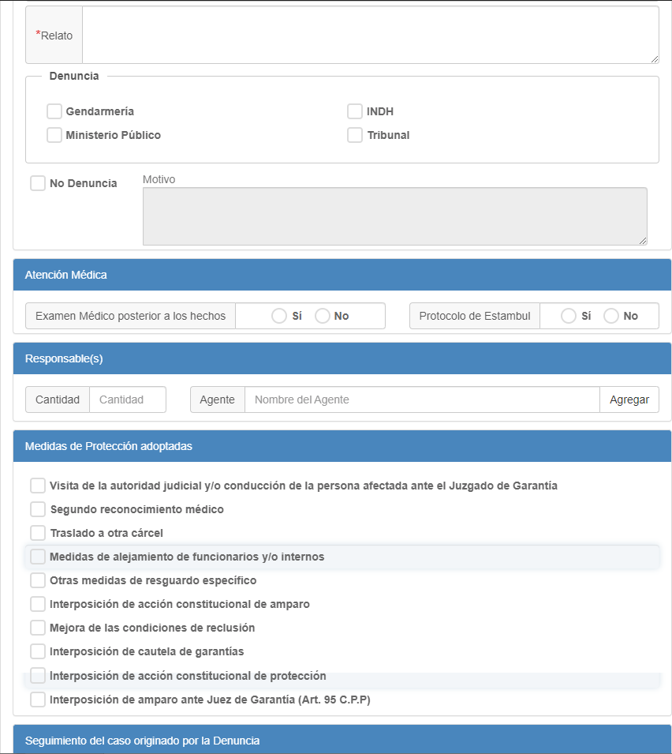
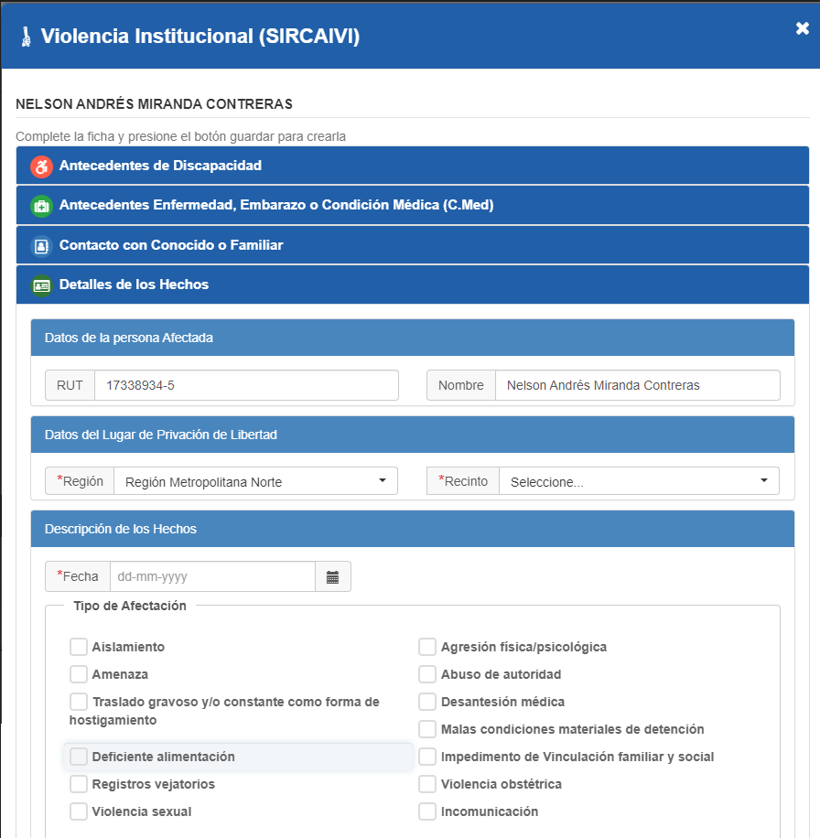

The computer system makes SIRCAIVI operational, by allowing the public defenders to register their cases, the actions they have taken regarding the victims, and all follow-up information. Furthermore, this computer system allows for updated statistical information on SIRCAIVI cases to be available at all times.

Oversight and Coordination

As stated above, the general coordination and oversight of SIRCAIVI is under the responsibility of the Human Rights Unit of the DPP’s National Office, which will carry out a series of functions set forth in the SIRCAIVI Protocol:

- The Regional Offices coordination regarding IPV cases.
- The permanent monitoring of cases of institutional prison violence that enter the SIRCAIVI.
- The coordination with other Units of the National Office in all matters within the scope of SIRCAIVI.
- The supervision of the SIRCAIVI Register’s updating.
- The follow-up, and if necessary, activation of the actions regulated in the SIRCAIVI Protocol.
- The creation and updating of the Map of Cases and the SIRCAIVI website.
- The publication of SIRCAIVI’s annual reports.

In addition, the Human Rights Unit is responsible for the coordination and promotion of the intersectoral actions required to provide comprehensive services to IPV victims. All intersectoral and interinstitutional coordination related to IPV cases is realized through a Working Table specifically created for these purposes.

Dialogue and Intersectoral Action Working Table

In an effort to promote interinstitutional cooperation for a comprehensive and effective approach to IPV cases, a Dialogue and Intersectoral Action Working Table (Mesa de Diálogo y Actuación Intersectorial - MEDAI) was established through an agreement signed between the DPP, the Public Prosecutor's Office, the National Human Rights Institute, the Fiscalía Judicial of the Supreme Court, the Legal Medical Service and Gendarmeria de Chile. This Working Table’s function is to exchange information on victims of IPV with the aim of safeguarding their rights and providing them with comprehensive protection.

The DPP’s Human Rights Unit serves as MEDAI’s Technical Secretariat. In this role, it is responsible for the general coordination of the Table’s work, and in particular, to facilitate the realization of the intersectoral actions needed for the provision of comprehensive services to IPV victims. In this respect, MEDAI is a valuable resource for the coordination with other public institutions that can provide services outside the sphere of the DPP’s competencies.

So far, MEDAI has held four sessions. One of its first findings was that currently, it is not possible to extract comparable information on cases of IPV from the internal records that each institution keeps - because each institution records information with its own parameters according to the functions it performs - so the need arose to know the type of information that each institution collects and to evaluate possible ways to improve the collection of precise information on prison violence in each one, in order to advance towards the generation of more complete figures regarding the reality of IPV in Chile. Another concern raised at its first sessions was the need to analyze the concept of IPV, for the purpose of reaching a common definition that allows all MEDAI members to conduct a uniform approach to cases.

On the other hand, MEDAI has had the opportunity to carry out its first joint actions to provide comprehensive care to IPV victims. For example, in one case the victim was in a particularly vulnerable situation due to their individual circumstances and the risk of being subjected to reprisals for having reported the prison officials who had committed IPV against them, and urgently required psychological care. After discussing the case and the victim's specific needs, as well as the possibilities for intervention by each of the MEDAI members, the Public Prosecutor's Office managed to provide the psychological care that the inmate needed. This example shows how MEDAI can operate to fulfill specific victim’s needs for which the DPP cannot provide, but other public institutions can.

Currently, MEDAI is elaborating its own rules of operation, which will establish a formal procedure for the joint approach to cases. This will include duties to report the actions taken by each institution, as well as to jointly monitor the results of the actions taken.

SIRCAIVI’s First Findings

Between May 16th, 2022 and April 30th, 2023, SIRCAIVI has registered cases of prison violence regarding 148 individuals, of which 12 are women (5 convicted prisoners and 7 untried prisoners) and 136 are men (82 convicted prisoners and 54 untried prisoners).
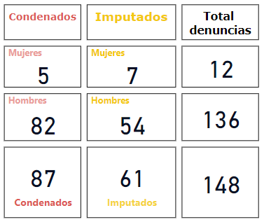

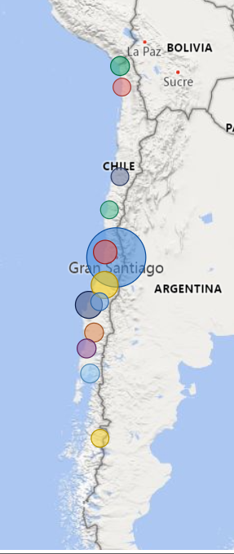
The map on the left shows the geographical distribution of SIRCAIVI cases. The Regions that concentrate the higher number or IPV cases are Santiago and Biobio.

Regarding the nature of IPV cases, the most frequently reported types of violence are physical or psychological assaults (36%), followed by abuses of authority (18%) and lack of medical attention (12%). In lesser numbers, inmates have reported cases of harmful transfers, threats, prolonged solitary confinement, and inadequate living conditions, such as a lack of electricity and heating during the winter, and insufficient beds.

Among women, the most frequent IPV types reported are physical or psychological assaults (17.9%), followed by threats, abuses of authority, and constant or harmful transfers (14.3% each). There’s also been 3 cases of obstetric violence reported by women. In one of them, the victim went into labor and was denied transportation to a hospital as well as health support. As a result, she gave birth in prison, without medical assistance.

Among men, the most frequent IPV types reported are physical or psychological assaults (37.8%), followed by abuse of authority (18.6%), and lack of adequate medical care (12.7%).

Regarding the willingness of victims to report IPV cases, 43 of the current 148 individuals with SIRCAIVI cases have expressed that they do not want their public defender to take any sort of action regarding their case. The most common reason given for this is fear to reprisals, followed by fear of losing work opportunities or other benefits.

Looking Forward: SIRCAIVI’s Prospective Impact and Challenges

In the first place, we expect SIRCAIVI’s operation will generate reliable figures about IPV in prisons throughout the country, including cases where the victims are not willing to press charges. Recording of these cases is particularly relevant, as it will allow us to approach the "dark figure" of prison violence, in terms that it is precisely these cases -where victims do not want to file a complaint for fear of reprisals- that traditionally go unnoticed by the State -and particularly, by the Justice System- , and thus, do not appear in official statistics, contributing to the underestimation of the incidence of prison violence in Chile.

To achieve this first goal, the strengthening of the public defenders’ skills to detect cases of IPV and properly enter them into the computer system is essential. That is why during 2023, the DPP will be carrying out a training program for the Regional Offices’ public defenders, which will cover both the operation of SIRCAIVI and the conceptual and operational elements that defenders must know in order to enhance System's potential. These trainings will specifically address the role of public defense in preventing torture and conducting effective interviews with IPV victims who are in custody, in accordance with the international standards established in the Istanbul Protocol.

As we make progress in improving the detection and recording of cases, the next challenge will be to strengthen the capacities to provide comprehensive care of IPV victims, where MEDAI plays a key role. To improve the capacity to generate inter-institutional coordination to provide comprehensive care, it may eventually be necessary to evaluate the convenience of incorporating new members to MEDAI, such as the health sector.

It is our expectation that the proper functioning of SIRCAIVI will build the trust of inmates to report their IPV cases, which will allow the data collected by the System to be a true reflection of reality. This requires that during the operation of SIRCAIVI, the focus is placed on the effective protection of inmates who report IPV cases.

Similarly, we expect the effectiveness of the System and the ongoing monitoring of inmates, both by the DPP and the members of MEDAI, to generate the effect of discouraging IPV and strengthening the effectiveness of protective mechanisms provided by the legal system.

Finally, in the long term, we expect that SIRCAIVI’s quantitative and qualitative information will serve as a valuable input for the development of more effective public policies and the adoption of corrective measures focused on the specific reality of each prison. Furthermore, at its core, this System aims to promote substantial changes in institutional practices that tolerate and perpetuate IPV, both by prison officials and other public institutions operating in this area. Indeed, eradicating IPV requires profound changes that go beyond the possibilities of SIRCAIVI. However, this System constitutes an innovative initiative that fills the existing gap in two key aspects: the reliable registration of IPV cases and the formalization of intersectoral coordination duties among the main public institutions that must act to combat IPV. In this sense, MEDAI allows the work of the prison administration, the prosecution, and the defense lawyers of IPV victims to be oriented in the same direction, in order to provide victims with effective protection. It is expected that this joint work will also help each institution to visualize the areas in which they must make internal corrections and improvements, within the scope of its legal competences, to effectively fulfill its legal responsibilities regarding IPV as well as Chile's international obligations regarding the human rights of persons deprived of their liberty. In this regard, promoting timely and effective investigation of all IPV cases -and especially of the most severe ones- is essential to comply with the international duty to guarantee prisoners’ human rights, considering that “[a]ttached to the peremptory and absolute prohibition of torture are obligations to investigate all acts of torture or other cruel, inhuman or degrading treatment or punishment, to prosecute […] suspects, to punish those responsible and to provide remedies to victims”.

I/A Court H.R., Case of Barreto Leiva v. Venezuela. Merits, Reparations and Costs. Judgment of November 17, 2009, para. 29.
Unconvicted prisoners are referred as “untried prisoners” in the Nelson Mandela Rules: “Persons arrested or imprisoned by reason of a criminal charge against them, who are detained either in police custody or in prison custody (jail) but have not yet been tried and sentenced” (Rule #111).
Gendarmería de Chile is a public agency, dependent on the Ministry of Justice, whose purpose is to attend to, monitor, and contribute to the social reintegration of people who are detained or deprived of liberty. It should be noted that the Chilean prison system is a mixed system, where some facilities are publicly operated and others are operated by private companies. In both systems, security and discipline is provided by Gendarmería de Chile.
Both are public servants from the DPP.
Report of the Special Rapporteur on torture and other cruel, inhuman or degrading treatment or punishment, Alice Jill Edwards: “Good practices in national criminalization, investigation, prosecution and sentencing for offences of torture”. Advance edited version, 13 March 2023, A/HRC/52/30, para. 20.

